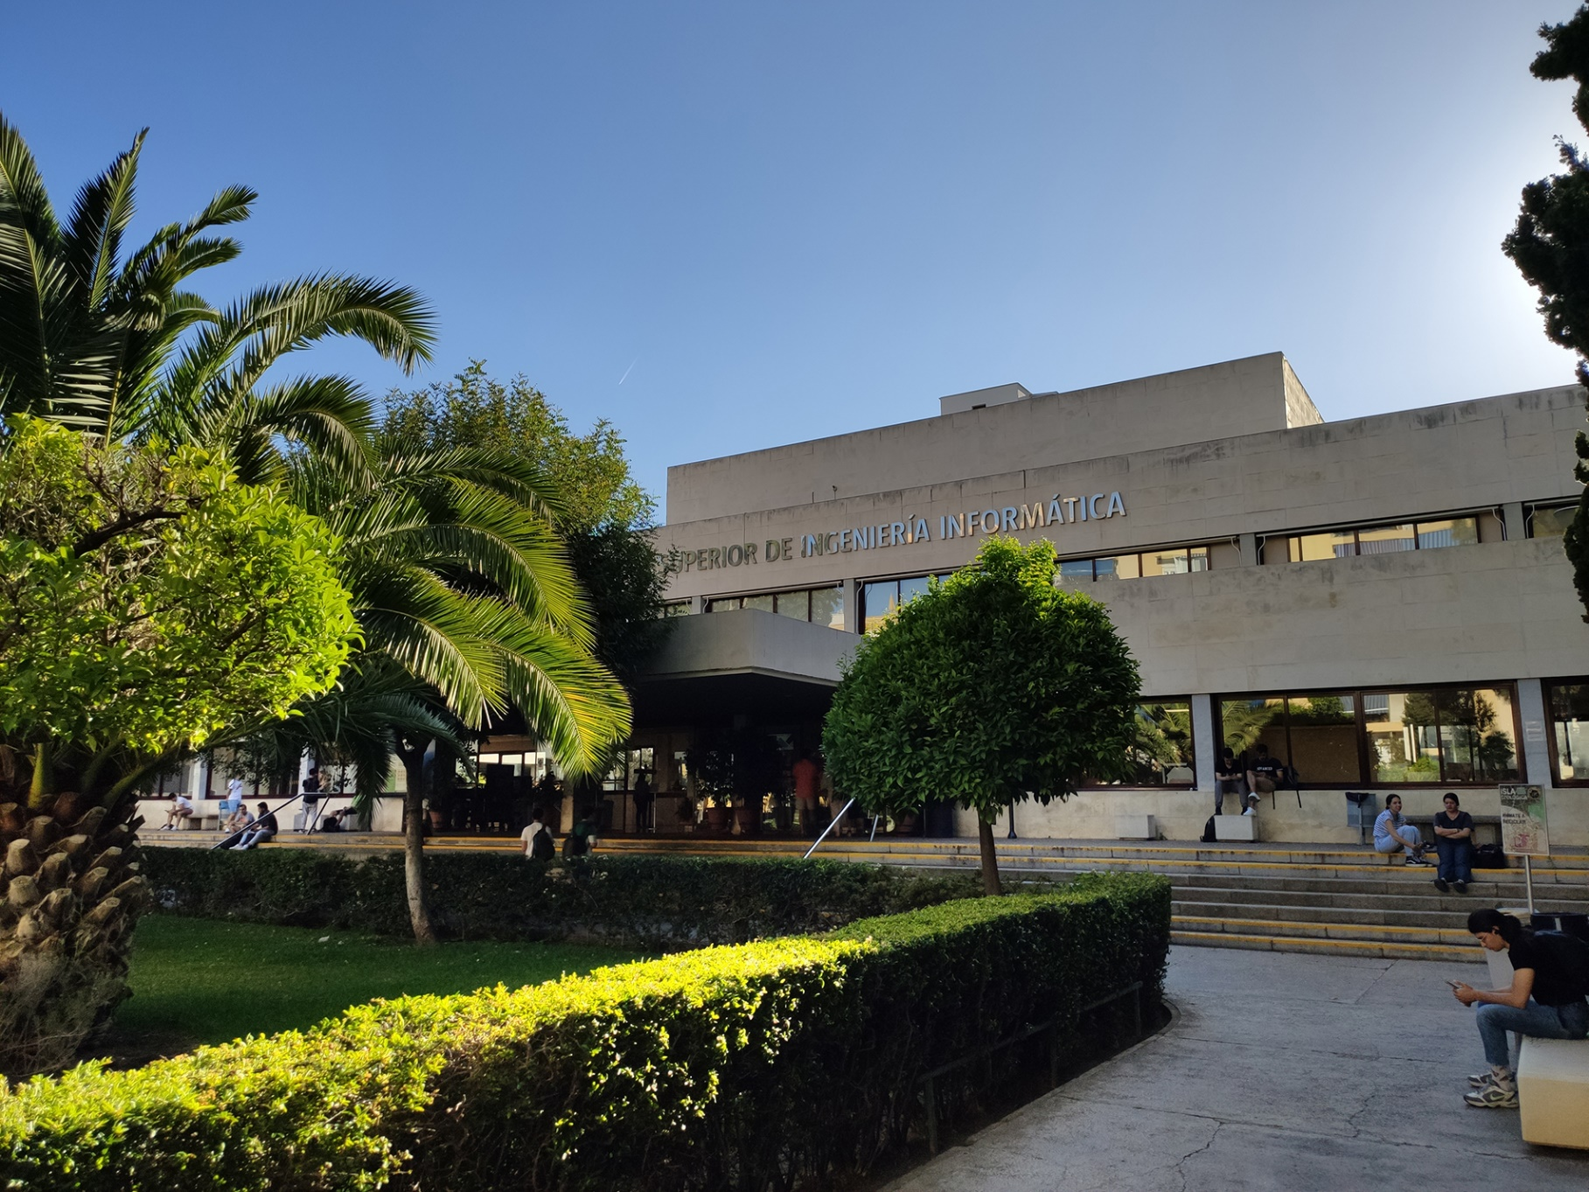

|  |
| --- |
| Analysis Report  Group |
| Jesús Cárdenas Conejo  (jescarcon@alum.us.es) |
| 17-02-2023  Group: C1.02.10  Repository: https://github.com/IsmaelRuizJurado/Acme-L3-D02 |



Table of Contents

Executive Summary 3

Version History 4

Introduction 5

Contents 6

Conclusions 7

Bibliography 8

# Executive Summary

In this report you will find relative information of my deliverable in an Analysis Report structure. This document shows how many analyses record I have redacted, the content of those reports and a link to the forum where a lecturer gave us insight, if the requirement needed an outside help for interpretation.

# Version History

|  |  |  |
| --- | --- | --- |
| Version | Date | Description of changes |
| 1.0 | 8/03/2023 | Creation of the Analysis Report Document. |

# Introduction

In this report we are going to describe the analysis and decision that I have made in the process of finding a solution for the problem that is stated on the deliverable 2, the documentation requirement we decided that we are going to only take in account the requirements that involves touching the code because the documentation has no decision to be made because we will follow the indications on the annexes.

Four requirements I choose to analyze in this report, for each of them we will provide a verbatim copy of the exercise, the analysis and the decision that have been made in seek of the solution and the link to the forum for the feedback of the lecturer if needed.

# Contents

Analysis of Requirement #1:

Verbatim copy of the exercise:

“There is a new project-specific role called lecturer, which has the following profile data: alma mater (not blank, shorter than 76 characters), a résumé (not blank, shorter than 101 characters), list of qualifications (not blank, shorter than 101 characters), and an optional link with further information.”

After reading this text I create the Lecturer Role without problems but the professor told us that url links needs also @NotBlank because a bug.

Analysis of Requirement #2:

Verbatim copy of the exercise:

“A course aggregates several lectures by the same lecturer. The system must store the following data about them: a code (pattern “[A-Z]{1,3} [0-9]{3}”, not blank, unique), a title (not blank, shorter than 76 characters), an abstract (not blank, shorter than 101 characters), an indication on whether it can be considered a theory course or a hands-on course (depending on the lectures that it aggregates), a retail price (positive or nought), and an optional link with further information. Purely theoretical courses must be rejected by the system.”

After reading this case, I decide after analise it that I will create in the Course Entity with the atribute Course_Type which is an enumerate of two values: THEORETICAL and HANDS-ON. Also I linked it with lecturer with a ManyToOne relation.

Analysis of Requirement #3:

Verbatim copy of the exercise:

“A lecture is a document that a lecturer uses to get some knowledge across. The system must store the following data about them: a title (not blank, shorter than 76 characters), an abstract (not blank, shorter than 101 characters), an estimated learning time (in hours, positive, not nought), a body (not blank, shorter than 101 characters), an indication on whether it can be considered theoretical or hands-on, and an optional link with further information.”

After reading this case, I decide after analise it that I will create in the Lecture Entity with the atribute Lecture_Type which is an enumerate of two values: THEORETICAL and HANDS-ON. Also I linked it with course with a ManyToOne relation.

Analysis of Requirement #4:

Verbatim copy of the exercise:

“The system must handle lecturer dashboards with the following data: total number of theory and hands-on lectures; average, deviation, minimum, and maximum learning time of the lectures; average, deviation, minimum, and maximum learning time of the courses”

After reading this case, I decide after analise it that I will create in the Dashboard Form with an auxiliary class call Stats , it collect all the statistic numerical variables.

# Conclusions

The group and I followed the theory material and the teacher advice, so we did a better work in less time thanks to the learned knowledge in the first deliverable.

# Bibliography

Intentionally blank.